Readme for Installations of Eclipse and setting it up for python

1. Click [Eclipse](http://www.eclipse.org/downloads/packages/release/Luna/R)

The following page will appear in your browser. In this handout we will download **Eclipse Standard 4.4** for Windows 32 Bit; if your computer uses Windows, continue below; otherwise look for the pull-down list showing **Windows** and instead choose either **Mac OS X (Cocoa)** or **Linux** and then continue below.

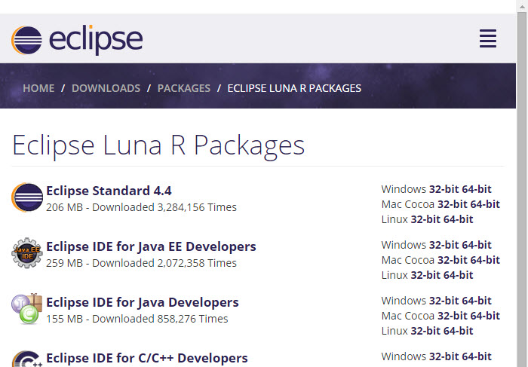

It is critical that Java, Python, and Eclipse are either all 32 Bit or are all 64 Bit (and only if your Machine/OS supports 64 Bit): I think it easiest to use 32 Bit for everything.

1. Click the **Windows 32 Bit** Operating System for your machine, under the heading **Eclipse Standard 4.4** (right under **Package Solutions**).

You will see the following page (don't worry about the name of the institution to the right of the big downward pointing arrow).

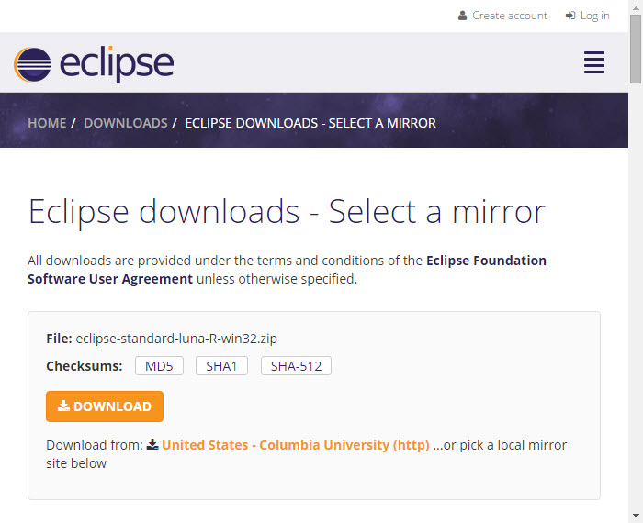

1. Click the orange **DOWNLOAD** button. The site named here, in orange to the right of the button: **United States - Columbia University (http)** is the random one chosen by the download page this time; yours may differ.

This file should start downloading in your standard download folder, while showing a splash screen about donating to Eclipse. This file is about 200 Mb so it might take a while to download fully if you are on a slow internet connection (it took me about 5 minutes over a cable modem). Don't worry about the exact time as long as the download continues to make steady progress. In Chrome progress is shown on the bottom-left of the window, via the icon

https://www.ics.uci.edu/~pattis/common/handouts/pythoneclipsejava/images/eclipse/downloadprogress.jpg

The file should appear as

https://www.ics.uci.edu/~pattis/common/handouts/pythoneclipsejava/images/eclipse/downloadfile.jpg

Terminate the window browsing the Eclipse download.

1. Move this file to a more permanent location, so that you can install Eclipse (and reinstall it later, if necessary).
2. Start the **Installing** instructions directly below.

### Installing (for Python)

**Python and Java should be installed before installing Eclipse**

1. Unzip **eclipse-standard-luna-R-win32.zip**, the file that you just downloaded and moved.   
   On my machine (running Windows 7), I can
   * Right-click the file.
   * Hover over the **IZArc** command from the menu of options.
   * Click **Extract Here**

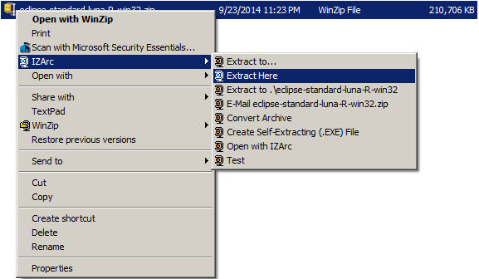

If you do not have IZArc or an equivalent unzipping program, here is the web site to download a free copy of [IZarc](http://izarc.org/downloads" \t "_blank).

Unzipping this file creates a folder named **eclipse**; unzipping 200 MB can take a few minutes. You can leave this folder here or move it elsewhere on your hard disk. I recommend putting the downloaded file and resulting folder in the **C:\Program Files\** directory.

1. Create a shortcut on your desktop to the **eclipse.exe** file in this **eclipse** folder: https://www.ics.uci.edu/~pattis/common/handouts/pythoneclipsejava/images/eclipse/eclipseexe.jpg   
   On most Windows machines, you can
   * Right-press the file **eclipse.exe**
   * Drag it to the desktop.
   * Release the right button.
   * Click **Create shortcut here**

Now you are ready to perform a **one-time only** setup of Eclipse on your machine.

1. Double-click the shortcut to Eclipse that you just created above.

If the following **Security Warning** window appears

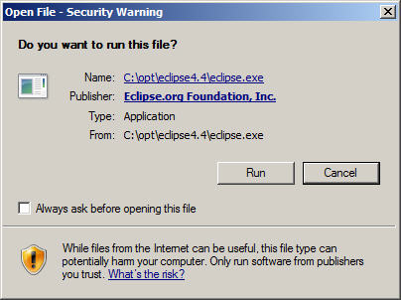

* + Uncheck the **Always ask before opening this file** checkbox
  + Click **Run**

The following splash screen will appear



and then a **Workspace Launcher** pop-up window will appear.

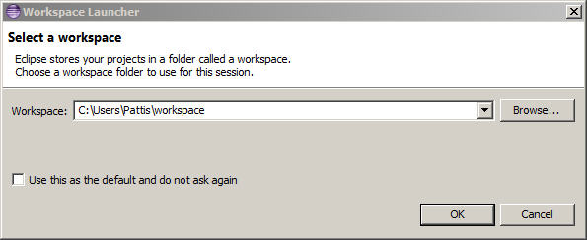

In the **Workspace** text box, your name should appear between **C:\Users\** and **\workspace**, instead of **Pattis**.

Leave **unchecked** the **Use this as the default and do not ask again** box. Although you will use this same workspace for the entire quarter (checking projects in and out of it), it is best to see this**Workspace Launcher** pop-up window each time you start Eclipse, to remind you where your workspace is located.

In fact, it is a good idea to create on your desktop a shortcut to your workspace folder; but you must click **OK** (see below) before Eclipse creates this folder and you can create a shortcut to it.

1. Click **OK**.

Progress bars will appear as Eclipse loads.

Eventually the Eclipse workbench will appear with a **Welcome** tab covering it.

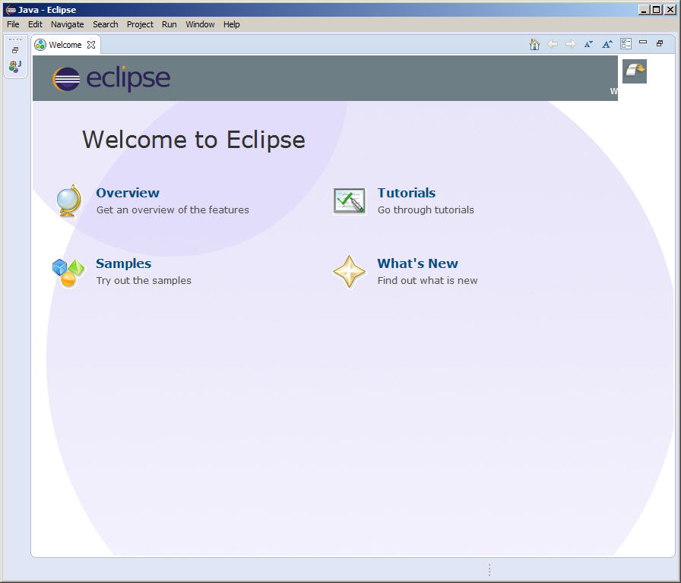

1. Terminate (click **X** on) the **Welcome** tab.

You will not see the **Welcome** tab when you start Eclipse again, after this first time.

1. Click **Help** (on the far right of the line below this window's blue title **Java - Eclipse**) and then click **Install New Software...** in its pull-down menu, as shown below.

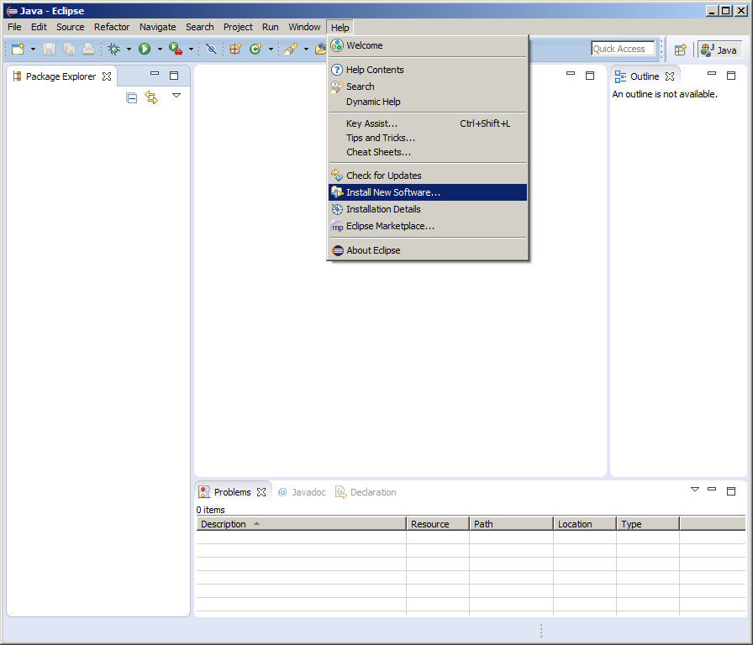

The **Install** pop-up window will appear.

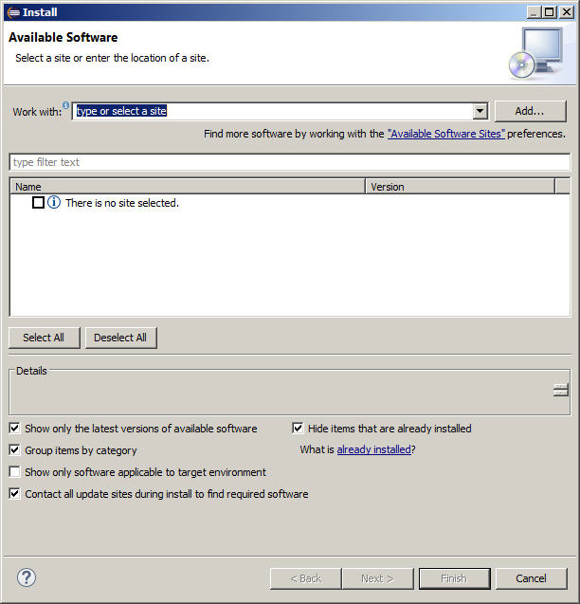

1. Enter the text (or cut/paste from this document) **http://pydev.org/updates** into the **Work with** text box and press **Enter** (if that doesn't work, try **http://www.pydev.org/updates**).

In a few seconds the information under **Name** should change from  
**There is no site selected** to **Pending** to

https://www.ics.uci.edu/~pattis/common/handouts/pythoneclipsejava/images/eclipse/pydev.jpg

Select only the top **PyDev** checkbox; do **NOT** select the **PyDev Mylyn Integration (optional)** box.  
Check before proceeding that the **Install** pop-up window appears as

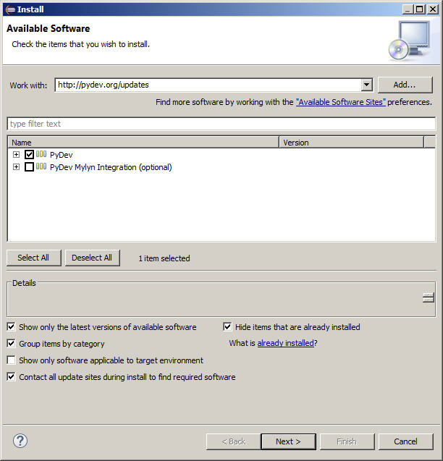

1. Click **Next >**

A new **Install** pop-up window will appear.

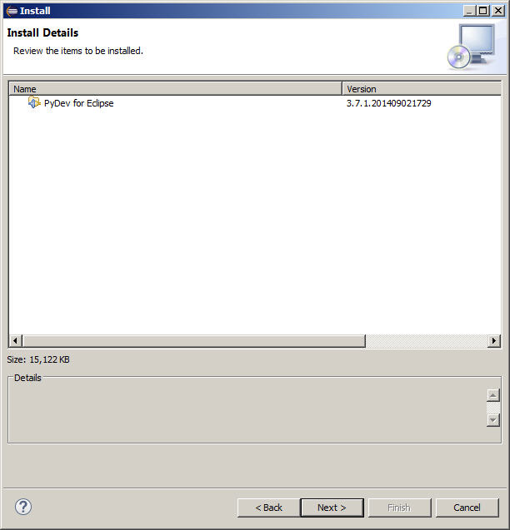

1. Click **Next >**

A new **Install** pop-up window will appear.

Select the **I accept the terms of the license agreement** radio button, so the window appears as

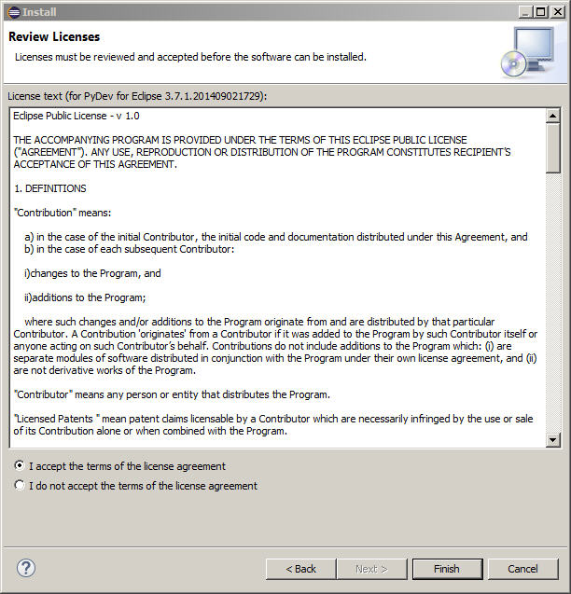

1. Click **Finish**

An **Installing Software** pop-up window will appear. During installation, it will show the various operations it is performing and a progress bar for each one. Because the installer is fetching various files online, this process might take a few minutes.

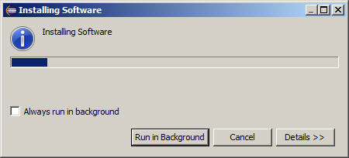

The installation will pause, and a **Selection Needed** pop-up window appears.

1. Check the box labeled **Brainwy Software; Pydev; Brainwy**.

Check before proceeding that the **Install** pop-up window appears as

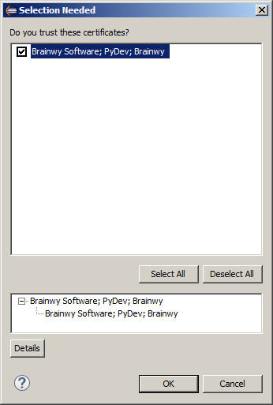

1. Click **OK**

The installation will finish (showing the final progress bars).

A **Software Updates** pop-up window will appear.

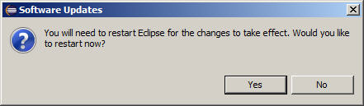

1. Click **Yes**

Eclipse will terminate and restart. As you did in step 3, click **OK** to the **Workspace Launcher** pop-up window.

1. Click **Window** (to the left of **Help** on the far right of the line below this window's blue title **Java - Eclipse**) and then click **Preferences** in its pull-down menu, as shown below.

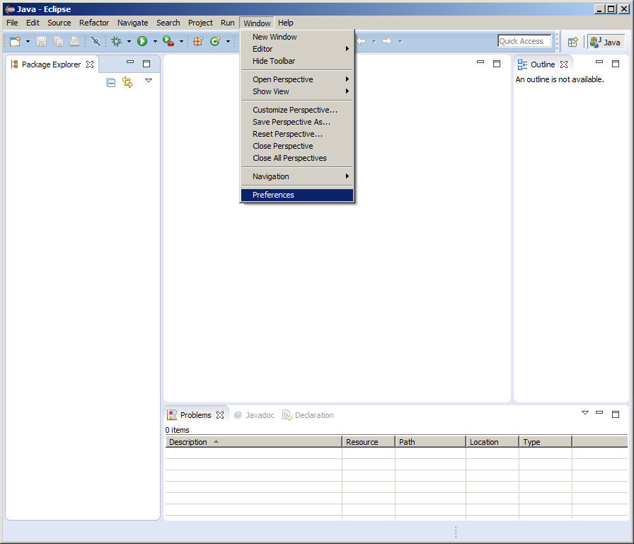

1. Drill down to select the interpreter:
   * Disclose **PyDev** by clicking the **+** in front of **PyDev** or double-clicking **PyDev** (after the +); the **+** changes to a **-**.
   * Disclose **Interpreters** by clicking the **+** in front of **Interpreters** or double-clicking **Interpreters** (after the +); the **+** changes to a **-**.
   * Select **Python - Interpreter**.

The **Preferences** pop-up window should appear as follows

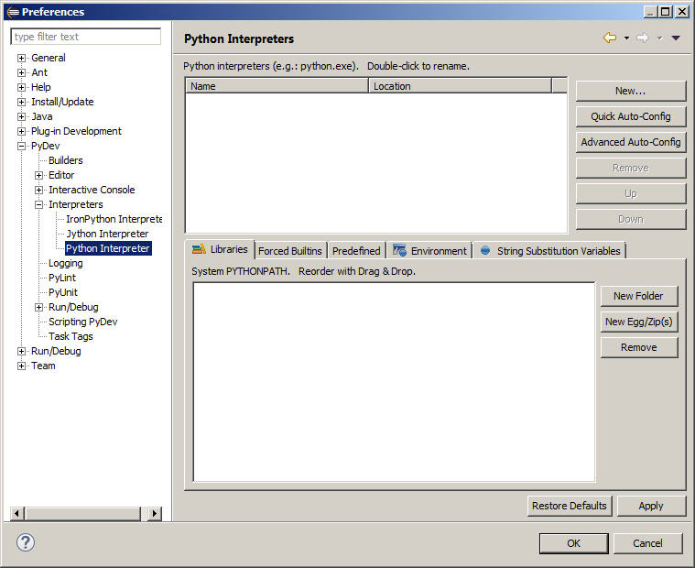

1. Click **New...** at the top-right of the top window

A **Select Interpreter** pop-up window appears.

Type **Python34** in the **Interpreter Name** text box.  
Type (or cut/paste) **C:\Python34\python.exe** in the **Interpreter Executable** text box (or browse to this file).  
The **Select Interpreter** pop-up window should appear as

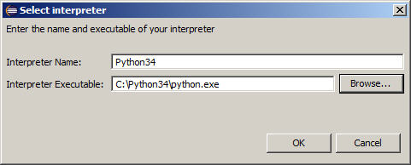

1. Click **OK**.

A **Selection needed** pop-up window will appear.

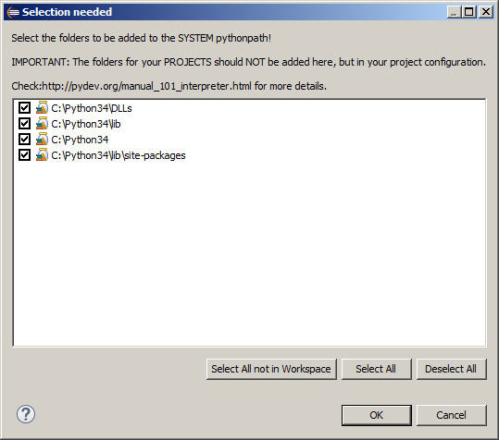

Ensure that a check appears in all four checkboxes.

1. Click **OK**.

The **Preferences** pop-up window will be changed to

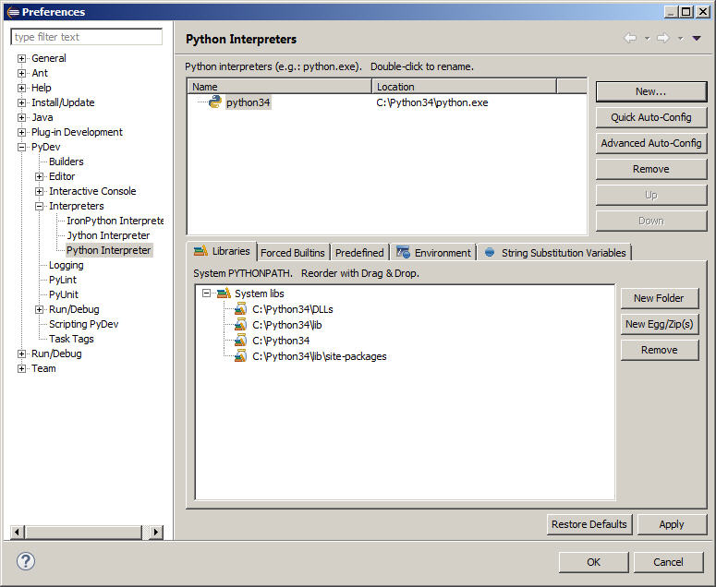

1. Click **OK**.

A **Progress Information** pop-up window will appear.

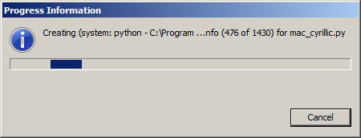

During installation, it will show the various operations it is performing and a progress bar for each one. Eventually the installation will terminate.

If the following pop-up window appears

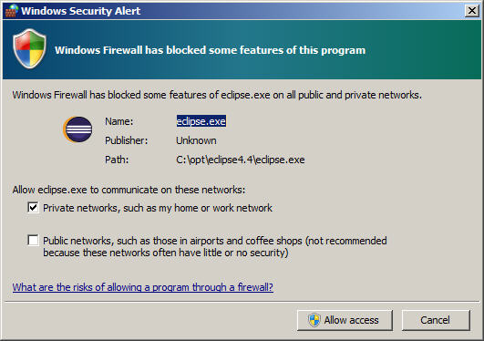

Ensure the **"Private networks, such as my home or work network"** checkbox is checked, and click **Allow Access**.

1. Click **Window** (to the left of **Help** on the far right of the line below this window's blue title **Java - Eclipse SDK**), hover over **Open Perspective** in the pull-down menu and then click **Other...** in the next pull-down menu.

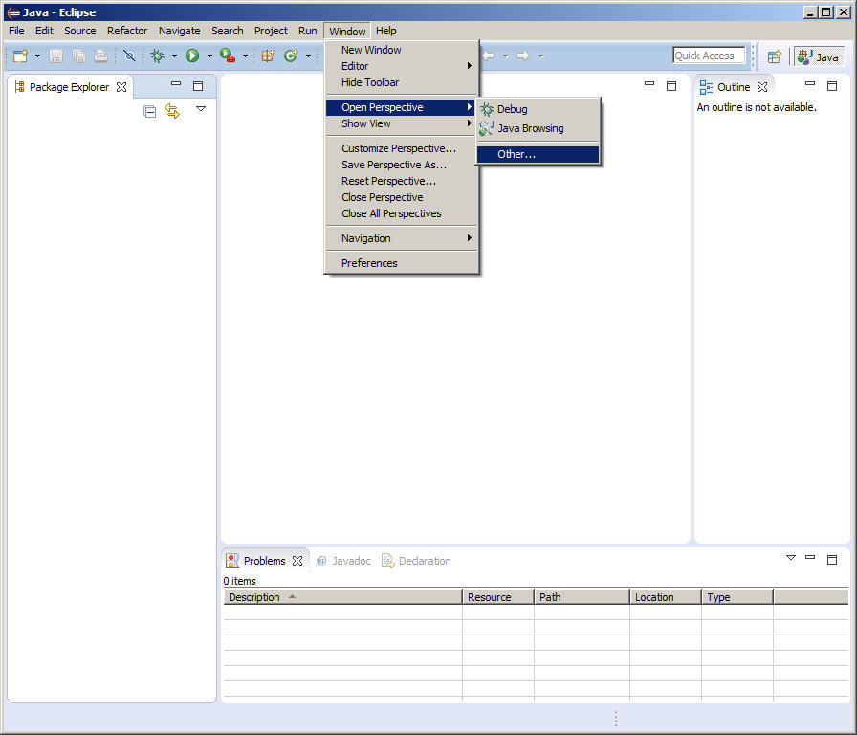

The **Open Perspective** pop-up window will appear.

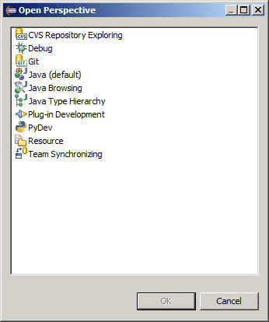

1. Double-click **PyDev** (third from the bottom)

The blue label on the Eclipse window will change to **PyDev - Eclipse**, the **Package Explorer** in the upper-left tab will change to **PyDev Package Explorer**, and a **PyDev** icon will appear to the right of the **Java** icon.

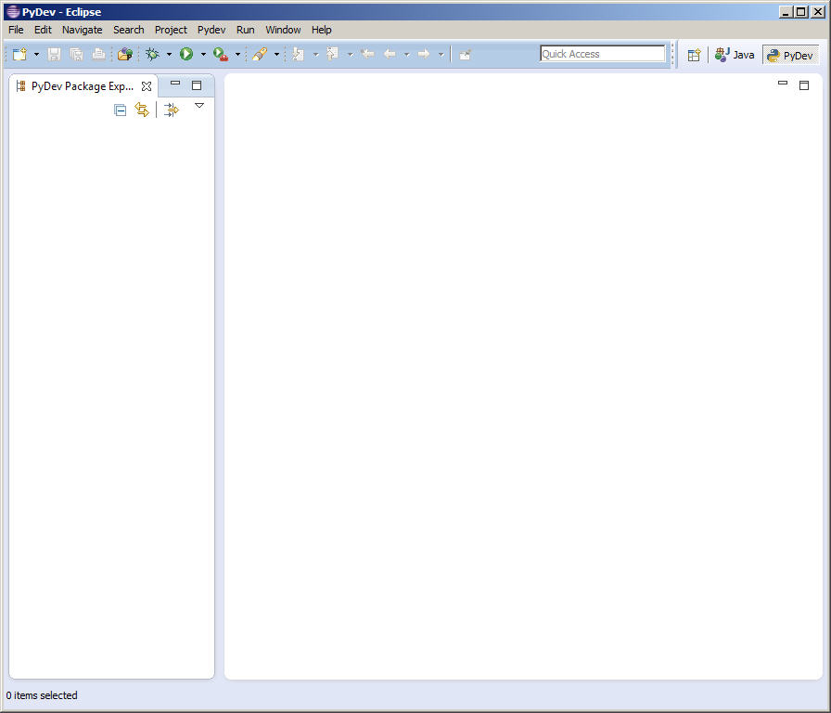

1. Right-click the **Java** icon to the left of the **PyDev** icon and select **close**

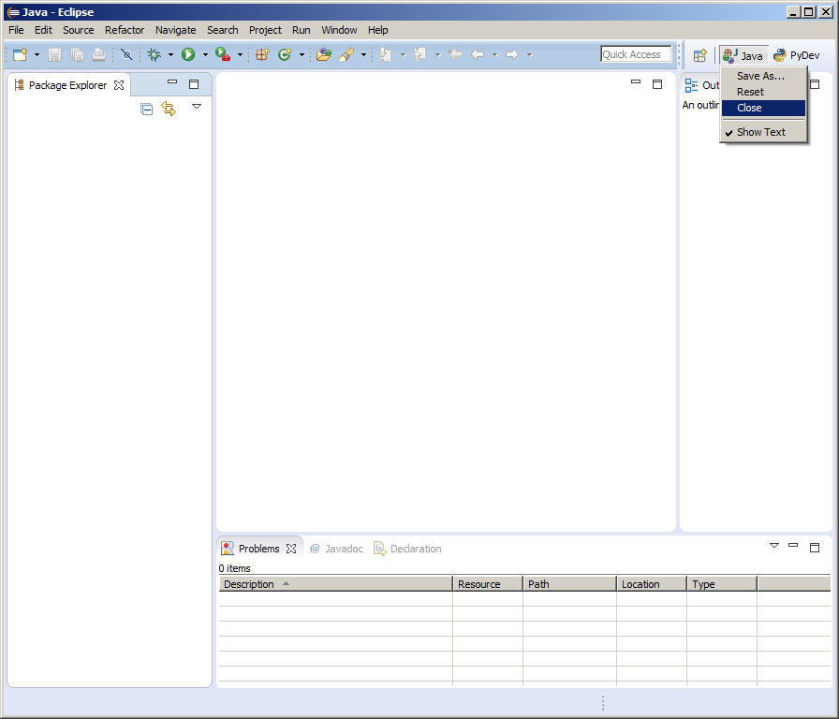

The Eclipse workbench will now have only the **PyDev** icon here and will look like

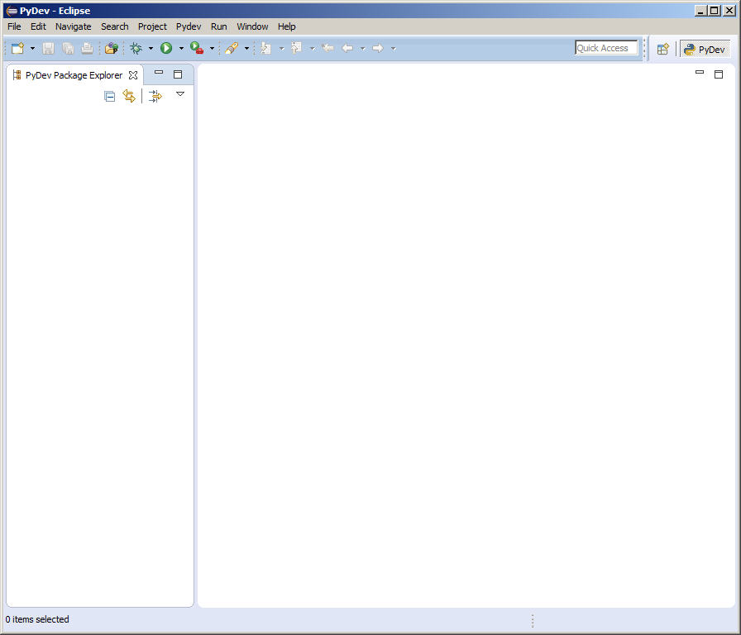

1. Locate the workspace folder created in step 3 (see **C:\Users\*yourname*\workspace**) and download the [<="" b="">courselib.zip](https://www.ics.uci.edu/~pattis/common/modules/courselib.zip) file into this workspace and unzip it there, producing the **courselib** folder; it should should contain a bunch of Python module files (ending in **.py**). From time to time you will be asked to put other course-specific Python module files into this **courselib** folder; these modules will be usable in all Python projects in Eclipse.
2. Inform Eclipse to use the **courselib** folder in all Python projects.
   * Select **Window | Preferences**.
   * Disclose **PyDev** by clicking the **+** in front of **PyDev** or double-clicking **PyDev** (after the +); the **+** changes to a **-**.
   * Disclose **Interpreters** by clicking the **+** in front of **Interpreters** or double-clicking **Interpreters** (after the +); the **+** changes to a **-**.
   * Select **Python - Interpreter**.



* + Click the **Libraries** tab (leftmost, above the bottom pane)
  + Click the **New Folder** button (topmost, right of the bottom pane)
  + Browse to the **courselib** folder (added above) in the **Browse for Folder** pop-up window (**C:\Users\*yourname*\workspace\courselib**).
  + Click the **courselib** folder selected, and then click **OK**
  + Click **Apply** (you will see some progress bars)  
    The <b<preferences< b="">pop-up window should now appear as

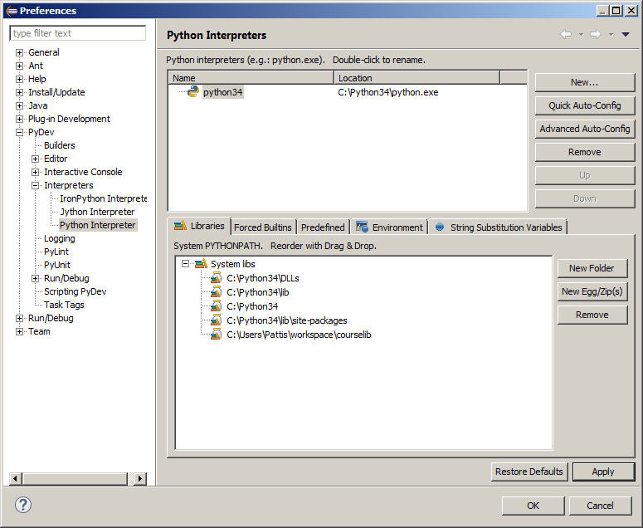

Notice a fifth entry (ending in **courselib** appears at the bottom of the bottom pane named **System PYTHONPATH**

</b<preferences<>

* + Cick **OK**

1. Terminate (click **X** on) the Eclipse window